# Reader Log: “Silicon Shelf”

Joshua Sears, Nick Critchfield

Phase: CS 340: Project Step 6 (Group, on Ed Discussions)

Due Monday, 6/12/23

Project URL: http://flip3.engr.oregonstate.edu:9036/index.html

Contents

Reader Log: “Silicon Shelf” 1

Executive Summary 2

Overview 3

Database Outline 3

❖ Readers (Object Entity) 3

❖ Books (Object Entity) 3

❖ ReadingClubs (Object Entity) 3

❖ ReadingLogs (Transaction Entity) 4

❖ ClubMembers (Composite Entity) 4

❖ ReadingStatus (Category Entity) 4

Entity-Relationship Diagram (ERD) 5

Schema 6

Example Data 7

Screen Captures of UI 9

## Executive Summary

This project started with a hefty seven entities in the first draft that offered multiple features for would-be users. In this initial model, we had a core three object entities: Readers, Books, and Reading Clubs. The other four entities each offered a “feature” to the users: a Club Members entity to register for Reading Clubs, a Reading Log to log reading activity, a Read Queue to order your reading list, and a Recommendation table to provide book recommendations to other users.

We reanalyzed our approach to this project going into step two and decided to focus on our core objects with just two “features” instead of four. This reduced our initial implementation to five entities. Because of how our Reading Log entity took shape, we also needed to add back a sixth small entity to pass the 3 normal form standards: a category entity for Reading Statuses. Additionally, in step two, we trimmed down attributes on our intersection tables (Club Members and Reading Log) to just the essential data point and foreign keys.

Initially, this project did not have a high-level ERD, instead it only had a more technical schema. To include the higher-level overview of the project, we reverse engineered from our schema the ERD now included.

The web implementation steps focused on creating an “administrator’s interface” for managing the database. This included full CRUD operations for all our entities, except for operations which we considered *tampering* with transactional data in our two transaction (intersection) tables.

A key part of our web implementation was deciding on technologies we would utilize in addition to the core stack of Node and MySQL. We decided against using a templating engine such as Handlebars. This way we would be in full control of DOM tree manipulations in our JavaScript.

Midway through web implementation, we needed to fully flush out how we were handling DELETE scenarios for M:N relationships. We added CASCADE constraints to our Club Members intersection table and SET NULL constraints to the Reading Log intersection table.

Our UI was enhanced by integrating the following feedback: adding a secondary navigation bar to allow navigating from entity to entity, loading display tables automatically, and adjusting datatypes for multiple attributes that were causing issue when attempting to add or modify data. After seeing other implementations, we incorporated ORDER BY clauses in our SELECT statements to make reviewing data in tables and drop menus easier for users.

## Overview

Silicon Shelf is a platform for tracking personal reading lists as well as coordinating reading with friends via reading clubs. A single user can add books to their own log, manage their reading list with status updates, track dates which they started and completed each book. Users may create and join reading clubs. This allows them to add a book to all their club members’ reading logs. With an anticipated 10,000 monthly active users and an average yearly enqueue rate of 10 books per user, a robust relational database is needed.

## Database Outline

### Readers (Object Entity)

* + readerID: INT, AUTO_INCREMENT, NOT NULL, PK
  + name: VARCHAR(50), NOT NULL
  + email: VARCHAR(50), NOT NULL
  + relations:
    - M:M Books through ReadingLogs
    - M:M ReadingClubs through ClubMembers

### Books (Object Entity)

* + bookID: INT, AUTO_INCREMENT, NOT NULL, PK
  + title: VARCHAR(50), NOT NULL
  + author: VARCHAR(50), NOT NULL
  + year: VARCHAR(10)
  + relations:
    - M:M Readers through ReadingLog
    - M:M ReadingClubs through ReadingLog

### ReadingClubs (Object Entity)

* + clubID: INT, AUTO_INCREMENT, NOT NULL, PK
  + clubName: VARCHAR(50), NOT NULL
  + relations:
    - M:M Readers through ClubMembers
    - M:M Books through ClubMembers

### ReadingLogs (Transaction Entity)

* + logID: INT, AUTO_INCREMENT, NOT NULL, PK
  + readerID: FK(Readers.readerID), ON DELETE SET NULL
  + bookID: FK(Books.bookID), ON DELETE SET NULL
  + readingClubID: FK (ReadingClubs.clubID), DEFAULT NULL, ON DELETE SET NULL
  + statusID: FK (ReadingStatus.status), ON DELETE SET NULL
  + timeStamp: DATETIME, DEFAULT, (CURRENT_TIMESTAMP)
  + relations:
    - 1:M Readers
    - 1:M Books
    - 1:M ReadingClubs
    - 1:M ReadingStatus

### ClubMembers (Composite Entity)

* + clubMemberID: INT, NOT NULL, AUTO _INCREMENT, PK
  + readerID: FK(Readers.readerID), NOT NULL, ON DELETE CASCADE
  + clubID: FK(ReadingClubs.clubID), NOT NULL, ON DELETE CASCADE
  + relations:
    - M:1 Readers
    - M:1 ReadingClubs

### ReadingStatus (Category Entity)

* + status: INT, NOT NULL, AUTO_INCREMENT PK
  + status: VARCHAR(50), NOT NULL

## Entity-Relationship Diagram (ERD)

## Schema

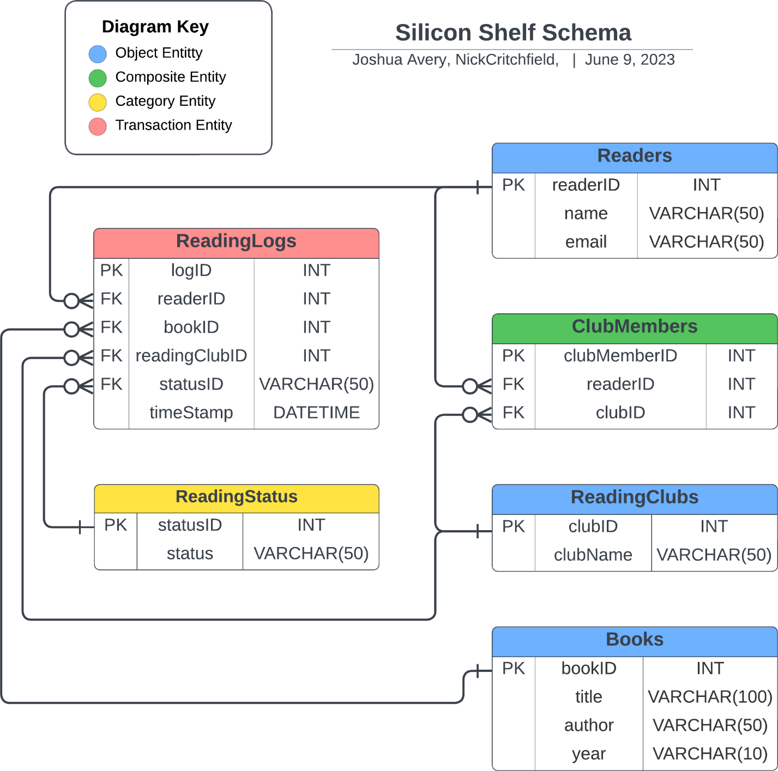

## Example Data

Sample data for Readers:

+----------+----------------------+---------------------------------------+

| readerID | name | email |

+----------+----------------------+---------------------------------------+

| 1 | Joseph McReading | j.mcreads@notreal.com |

| 2 | Sarah Jessica Booker | sjb@supercom.net |

| 3 | Mr. Adultman | doing.business@thebusinessfactory.com |

| 4 | Daniel Abraham | daniel.abraham@ghmail.com |

| 5 | Ro Himbo | rohimbo@derpinout.com |

| 6 | Jeroshi Yoshi | jer.yo@jeryo.cnet |

| 7 | Samuel Hackins | samuel.hackins@g.mail.com |

+----------+----------------------+---------------------------------------+

Sample data for Books:

+--------+---------------------------+------------------+------+

| bookID | title | author | year |

+--------+---------------------------+------------------+------+

| 1 | Leviathan Wakes | James S.A. Corey | 2011 |

| 2 | Gray's Anatomy | Henry Gray | 1858 |

| 3 | The Bell Jar | Sylvia Plath | 1963 |

| 4 | Finite and Infinite Games | James P. Carse | 1986 |

+--------+---------------------------+------------------+------+

Sample data for ReadingClubs:

+--------+---------------------+

| clubID | clubName |

+--------+---------------------+

| 1 | Tequila Mockingbird |

| 2 | Gone with the Gin |

| 3 | Nihilists Anonymous |

+--------+---------------------+

Sample data for ReadingStatus:

+----------+----------+

| statusID | status |

+----------+----------+

| 1 | Enqueued |

| 2 | Reading |

| 3 | Finished |

+----------+----------+

Sample data for ClubMembers:

+--------------+----------+--------+---------------+

| clubMemberID | readerID | clubID | isCoordinator |

+--------------+----------+--------+---------------+

| 1 | 1 | 1 | 0 |

| 2 | 6 | 1 | 0 |

| 3 | 3 | 1 | 0 |

| 4 | 4 | 3 | 1 |

| 5 | 5 | 3 | 0 |

+--------------+----------+--------+---------------+

Sample data for ReadingLogs:

+-------+----------+--------+---------------+----------+---------------------+

| logID | readerID | bookID | readingClubID | statusID | timeStamp |

+-------+----------+--------+---------------+----------+---------------------+

| 1 | 1 | 2 | 1 | 1 | 2023-05-02 10:22:38 |

| 2 | 6 | 1 | NULL | 3 | 2023-05-02 10:22:38 |

| 3 | 4 | 1 | 3 | 2 | 2023-05-02 10:22:38 |

| 4 | 2 | 3 | NULL | 1 | 2023-05-02 10:22:38 |

| 5 | 5 | 1 | 3 | 2 | 2023-05-02 10:22:38 |

+-------+----------+--------+---------------+----------+---------------------+

## Screen Captures of UI

Home Page with information about the present state of the application for administrators and development aim for users.

Administrator landing page with diagram and links to all entities.

Books entity: CREATE / RETRIEVE / UPDATE / DELETE

Books is in a M:N relationship with Readers through the ReadingLog intersection table. Note that both UPDATE and DELETE are present here.

ClubMembers entity: CREATE / RETRIEVE / DELETE

ReadingClubs entity: CREATE / RETRIEVE / UPDATE / DELETE

ReadingClubs is in a M:N relationship with Readers through the ClubMembers intersection table. Note that both UPDATE and DELETE are present here.

ReadingLogs entity: CREATE / RETRIEVE

Readers entity: CREATE/ RETRIEVE / UPDATE / DELETE

Readers is in a M:N relationship with Books through the ReadingLog intersection table and with ReadingClubs through the ClubMembers intersection table. Note that both UPDATE and DELETE are present here.

ReadingStatus entity: CREATE / RETRIEVE / UPDATE / DELETE

